**NLP CHATBOT PROJECT**

# CHATGPT’s View:

Building a chatbot for your food delivery website using NLP involves several steps. Here's a step-by-step guide to help you through the process:

**Step 1: Define the Purpose and Features**

* **Identify Use Cases**: Determine what tasks the chatbot should perform, such as:
  + Answering FAQs about the food delivery service.
  + Taking orders.
  + Providing order tracking.
  + Offering promotions or discounts.
* **Define Features**: Outline specific features your chatbot will have, like:
  + Natural language understanding (NLU) for understanding user queries.
  + Integration with your food delivery system for order processing.
  + Support for multiple languages if needed.

**Step 2: Choose a Development Framework**

* **Select a Platform**: Choose a chatbot development framework. Some popular options include:
  + **Dialogflow**: Google’s NLP platform for building chatbots.
  + **Rasa**: An open-source machine learning framework for building contextual AI assistants.
  + **Microsoft Bot Framework**: A comprehensive framework for building chatbots.

**Step 3: Design Conversation Flow**

* **Create Conversation Scenarios**: Design the chatbot's conversation flow by mapping out user interactions. Use flowcharts or diagrams to visualize:
  + User inputs (e.g., "I want to order pizza").
  + Bot responses (e.g., "Sure! What type of pizza would you like?").
* **Identify User Intents**: Define various intents based on the user’s requests (e.g., order, track, inquire).

**Step 4: Build and Train the Chatbot**

* **Set Up the Environment**: Create a development environment using your chosen framework.
* **Define Intents and Entities**:
  + Intents: What the user wants (e.g., ordering food).
  + Entities: Specific details (e.g., food items, quantities).
* **Train the Model**: Use sample data to train your chatbot model to understand user intents and entities.

**Step 5: Implement NLP Capabilities**

* **Natural Language Understanding (NLU)**: Implement NLU to allow the chatbot to comprehend user inputs accurately. Configure the NLU model to recognize synonyms and variations in user language.
* **Dialog Management**: Implement dialog management to handle the flow of conversation based on user inputs.

**Step 6: Integrate with Food Delivery System**

* **API Integration**: Connect your chatbot to your food delivery system using APIs to enable:
  + Order placement.
  + Order tracking.
  + Menu retrieval.
* **Testing**: Ensure the integration works correctly by testing various user scenarios.

**Step 7: Test the Chatbot**

* **User Testing**: Conduct user testing to gather feedback on the chatbot’s performance.
* **Iterate**: Based on feedback, make necessary adjustments to improve the user experience.

**Step 8: Deploy the Chatbot**

* **Choose Deployment Channel**: Decide where to deploy your chatbot (e.g., website, messaging platforms like Facebook Messenger).
* **Integrate into Website**: Use HTML/CSS/JavaScript to embed the chatbot into your food delivery website.

**Step 9: Monitor and Improve**

* **Analytics**: Implement analytics to track user interactions and identify areas for improvement.
* **Continuous Improvement**: Regularly update and improve the chatbot based on user feedback and changing requirements.

**Conclusion**

Building and integrating an NLP chatbot into your food delivery website involves careful planning, design, and execution. By following these steps, you can create an effective chatbot that enhances the customer experience.

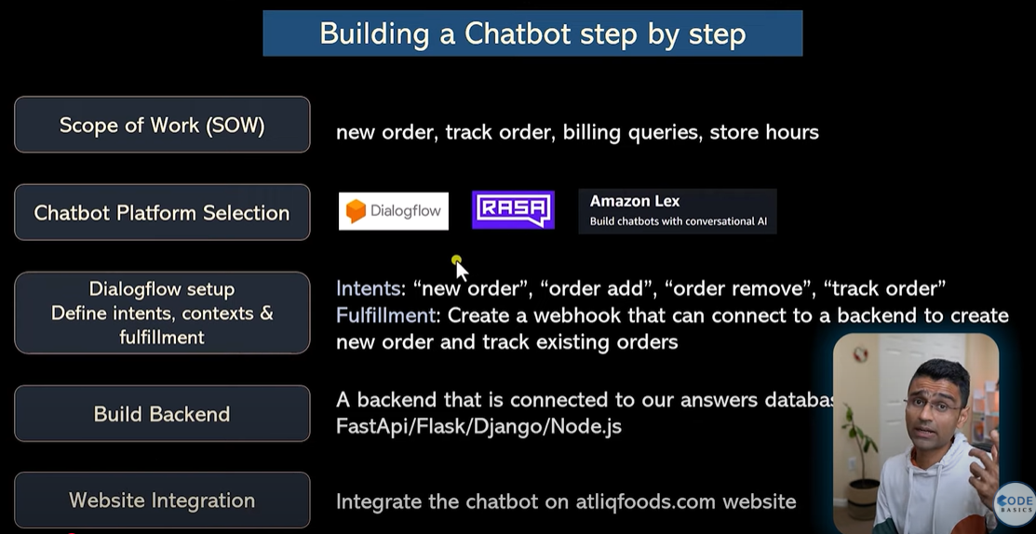

# Scope Of Words:

1. **Definition**: Scope refers to the boundaries of a project, including specific goals, deliverables, and tasks needed to achieve project objectives.
2. **Components**:
   * **Project Scope Statement**: Overview of the project, including objectives and deliverables.
   * **Deliverables**: Outputs the project must produce (e.g., reports, software).
   * **Requirements**: Criteria for success (e.g., functionality, quality).
   * **Boundaries**: Clarifies what is included and excluded to prevent scope creep.

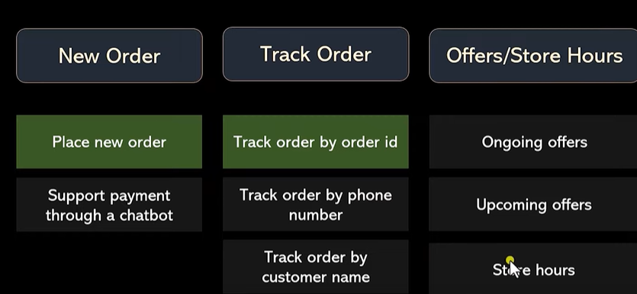

1. **Types of Scope**:
   * **Product Scope**: Features and functions of the product.
   * **Project Scope**: Work required to deliver the product.
2. **Scope Management Process**:
   * **Initiation**: Define scope and gather requirements.
   * **Planning**: Create a scope management plan.
   * **Execution**: Implement the project per the defined scope.
   * **Monitoring and Controlling**: Track progress and manage changes.
   * **Closure**: Ensure deliverables meet the defined scope.
3. **Importance**:
   * Provides clarity and control.
   * Prevents scope creep.
   * Facilitates resource management.
   * Measures project success.

**Example**

**Project: Mobile Application Development**

* **Scope Statement**: Develop a task management mobile app.
* **Deliverables**: User authentication, task management interface, notifications.
* **Boundaries**: Excludes marketing and post-launch support.

# Backlog:

A backlog, in the context of project management and software development, is a prioritized list of tasks, features, or items that need to be completed in order to achieve the goals of a project. It serves as a central repository for work that is planned but not yet started or completed. Here’s a breakdown of its key aspects:

**Key Components of a Backlog**

| **Component** | **Description** |
| --- | --- |
| **Items** | The tasks, features, bugs, or improvements that need to be addressed. |
| **Prioritization** | Items are typically prioritized based on factors like business value, urgency, or dependencies. |
| **Estimation** | Items may include estimates of the time or effort required to complete each task. |
| **Status** | Indicates whether items are in progress, completed, or still pending. |

**Types of Backlogs**

1. **Product Backlog**: A high-level list of all desired work on a product, maintained by the product owner. It includes features, bug fixes, and technical tasks.
2. **Sprint Backlog**: A subset of the product backlog that is selected for a specific sprint or iteration in agile development. It includes tasks that the team commits to completing in that time frame.
3. **Release Backlog**: A list of items planned for a specific release. It includes features and fixes that need to be completed before the product is delivered to users.

**Importance of a Backlog**

* **Organizes Work**: Provides a structured way to manage and organize work items.
* **Prioritization**: Helps teams focus on the most important tasks that deliver the highest value.
* **Transparency**: Increases visibility into the work to be done, making it easier for stakeholders to understand progress.
* **Adaptability**: Allows teams to adjust priorities based on changing requirements or feedback.

**Backlog Management Practices**

* **Regular Review**: Backlogs should be regularly reviewed and refined to ensure items are still relevant and prioritized correctly.
* **User Stories**: Often, backlog items are written as user stories to capture requirements from the user's perspective.
* **Collaboration**: Involving the team in backlog grooming ensures everyone understands the work and contributes to prioritization.

# MVP (Minimum Viable Product) in Simple Terms

* **Definition**: An MVP is the simplest version of a product that includes only the essential features needed to meet the core needs of users.
* **Purpose**: To test and validate ideas with real users before investing in full product development.
* **Key Features**:
  + **Basic Functionality**: Contains only the most critical features.
  + **User Feedback**: Allows users to provide feedback to improve the product.
  + **Quick Launch**: Faster to develop and launch compared to a full product.
* **Benefits**:
  + **Cost-Effective**: Saves time and resources by focusing on essentials.
  + **Market Testing**: Helps understand user preferences and market demand.
  + **Iterative Development**: Enables continuous improvement based on user input.
* **Examples**:
  + A simple app with just one key feature (e.g., a chat function in a chatbot).
  + A website with basic information before adding more complex features.

**Conclusion**

An MVP is a strategic approach to product development that prioritizes speed and user feedback to guide future improvements.

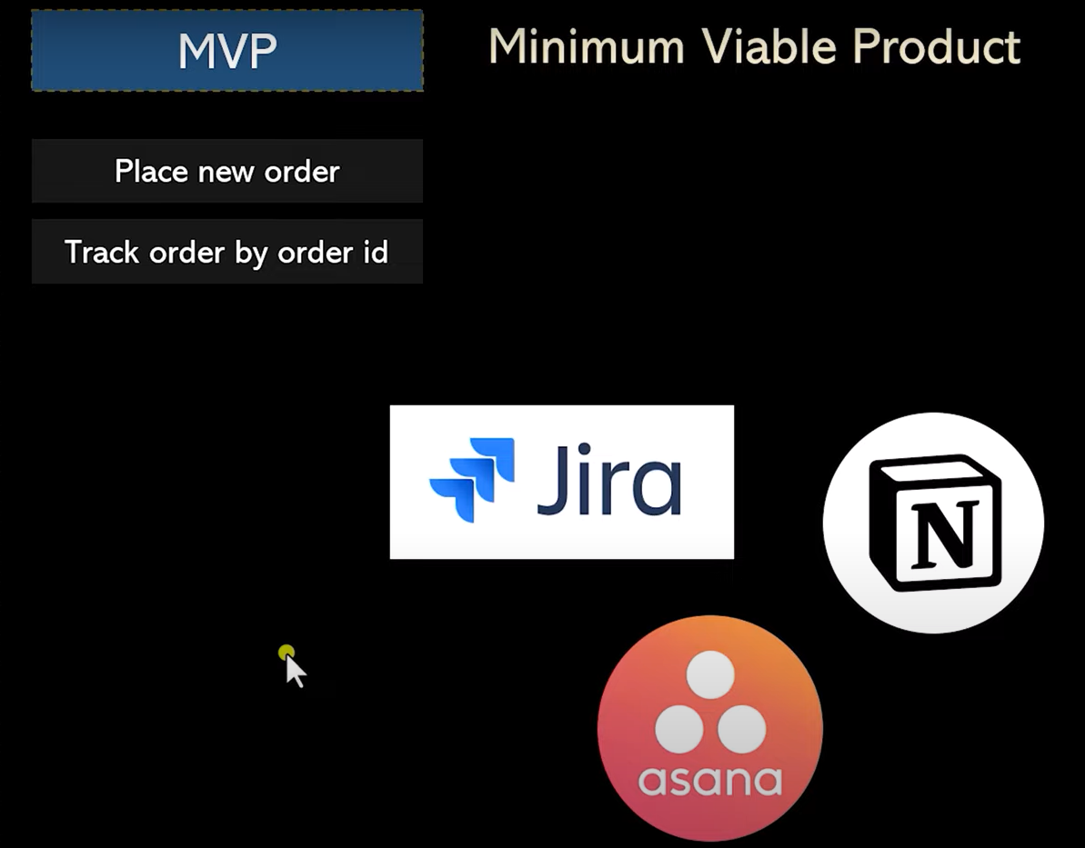

# Scrum

**Scrum** is an agile framework for managing complex projects, emphasizing teamwork, iterative progress, and customer feedback.

**Key Components**

1. **Roles**:
   * **Product Owner**: Manages the product backlog and defines the product vision.
   * **Scrum Master**: Facilitates the Scrum process and removes obstacles.
   * **Development Team**: Cross-functional team that delivers the product increment.
2. **Artifacts**:
   * **Product Backlog**: Prioritized list of features and tasks.
   * **Sprint Backlog**: Tasks selected for the current sprint.
   * **Increment**: Completed work at the end of a sprint.
3. **Events**:
   * **Sprint**: Time-boxed period for development (1-4 weeks).
   * **Sprint Planning**: Meeting to define sprint goals and tasks.
   * **Daily Scrum**: Short daily meeting for progress updates.
   * **Sprint Review**: Presentation of completed work to stakeholders.
   * **Sprint Retrospective**: Reflection on the sprint for continuous improvement.

**Example: Chatbot Development**

* **Product Owner**: Defines chatbot features (e.g., FAQ response).
* **Scrum Master**: Ensures Scrum practices are followed.
* **Development Team**: Implements features.

**Artifacts Example:**

* **Product Backlog**: User authentication, FAQ feature, analytics dashboard.
* **Sprint Backlog (Sprint 1)**: User authentication (5 tasks), FAQ feature (3 tasks).

**Event Flow:**

1. **Sprint Planning** → 2. **Daily Scrum** → 3. **Sprint Review** → 4. **Sprint Retrospective**

**Diagram**

Here's a simple diagram illustrating the Scrum framework:

plaintext

Copy code

+-----------------+

| Product Owner |

+--------+--------+

|

v

+-----------------+

| Product Backlog|

+-----------------+

|

v

+-----------------+

| Sprint Planning |

+--------+--------+

|

v

+-----------------+

| Sprint |

| (1-4 weeks) |

+--------+--------+

| Daily Scrum |

+--------+--------+

|

v

+-----------------+

| Sprint Review |

+-----------------+

|

v

+-----------------+

| Sprint Retrospective |

+-----------------+

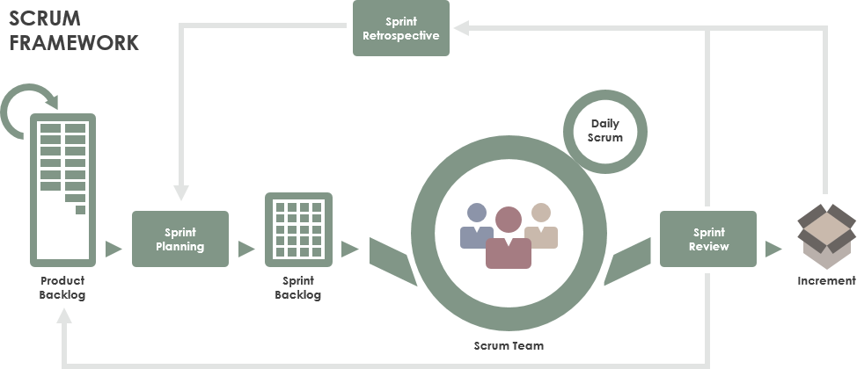

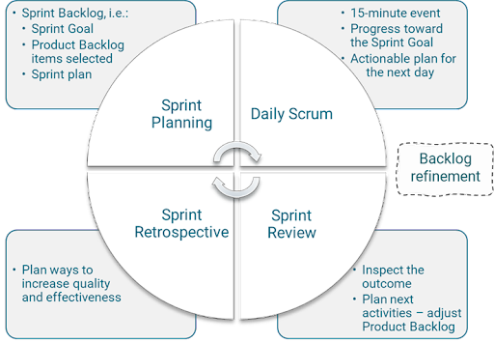

**Conclusion**

Scrum helps teams deliver value through collaboration, iterative development, and feedback. It's ideal for complex projects like software development, ensuring alignment with user needs and continuous improvement.

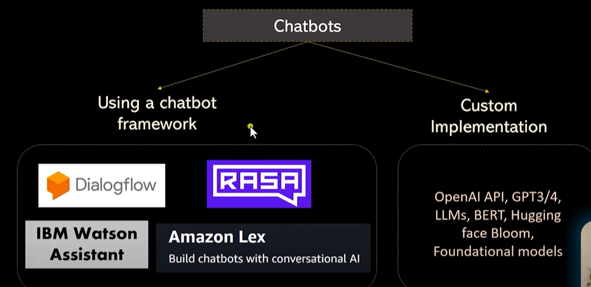

# Intent and Entity:

* **Intent**: Represents **what the user wants to achieve** or their goal in interacting with the chatbot.
  + **Example**: If a user says, "I want to order pizza," the **intent** is place_order.
* **Entity**: Represents **specific details or pieces of information** in the user's input that are required to fulfill the intent.
  + **Example**: In "I want to order a large pepperoni pizza," the **entities** are:
    - size: large
    - type: pepperoni

**Simple Example in a Food Delivery Chatbot**

**User Input:**

"I want to order a large cheese pizza."

* **Intent**:  
  place_order
* **Entities**:
  + size: large
  + type: cheese

**Another User Input:**

"Where is my order?"

* **Intent**:  
  track_order
* **Entities**:  
  No specific entity here; just the intent.

**Example with Multiple Entities**

**User Input:**

"Order two medium veggie pizzas and one large coke."

* **Intent**:  
  place_order
* **Entities**:
  + quantity: 2
  + size: medium
  + type: veggie pizza
  + quantity: 1
  + size: large
  + type: coke

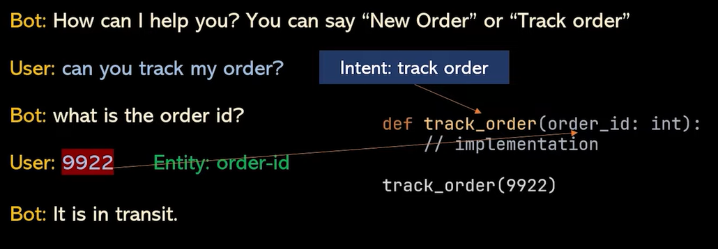

**Key Takeaway**

* **Intent** answers **"What does the user want?"**

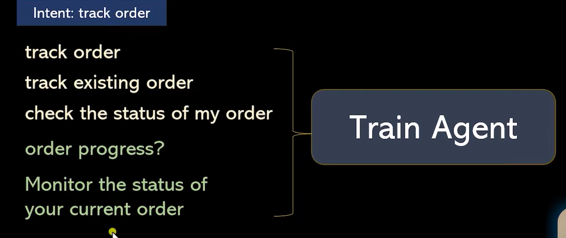

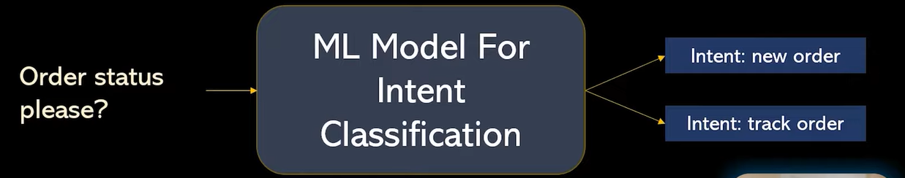

* **Entities** answer **"What details are needed to fulfill the user’s request?"**

By clearly defining intents and extracting entities, your chatbot can understand and respond effectively to user queries

